* **optical heart sensor: used to calculate blood oxygen level and heart rate**
* **utilizing green light: using a green light to measure heart rate from your wrist, through spectroscopy it shows that blood absorbs red, because red and blue are opposite each other on the colour wheel. the rear of these health smartwatches contains optic sensors used in detecting the reflected lights. The main difference from spectrometers is that the light source and detector are positioned on the same side in smartwatches, while they are opposite each other in spectrometers.**

* **SPO2 is the latest metrics used to measure oxygen saturation rate in the body, this is the percentage of haemoglobin found in the oxygen in your blood. Using pulse oximetry is the most common method used by healthcare to measure SPO2, the PO in watches used two sources of light being red and infrared, because oxygenated haemoglobin allows IR light to pass and absorb red light. Modern health smartwatches can measure Spo2 by using pulse oximetry and calculating the difference between IR and red light absorption from your wrist**
* **ECG - electrocardiogram used to measure the timing and strength of the electrical pulses that keeps the heart pumping**
* **accelerometer - mainly used in watches to track motion in a body, can be used to measure a person level of activity, whether they are walking, jogging or running.**
* **heart rate monitor used to monitor the heart rate and pulse; PPG (photoplethysmography) is the most widely used technology for heart-rate detection. It is a non-invasive detection method that uses photoelectric means to detect changes in blood volume. The PPG sensor in a smartwatch is usually composed of an LED light source and an optical detector. The LED light source will first shine green light onto the user’s wrist, and then the optical sensor detects the received reflected light and counted the amount of it. The skin on the wrist reflects more green light when there are more red blood cells in the blood vessels. Therefore, by tracking changes in the concentration of red blood cells in blood vessels, smart watches can realize the function of heart rate detection.Changes in heart rate are closely related to physical health, and too fast or too slow heart rate may be related to the disease. The regular heart rate of an adult in a quiet, awake state should be 60-100 beats per minute. By observing changes in heart rate through smart watches, we can discover potential health changes in the body in time.**
* **skin temperature sensors are used to measure the thermal energy from a body’s skin, this is used to measure the body temperature level. as there are different factors that can affect body temperature, e.g. physical activity, environment, etc. Smartwatches with skin temperature sensors can track subtle changes in skin temperature over time by keeping an eye on users’ body temperatures. It can then help detect potential illnesses early, as abnormal body temperature can be an early sign of physical illness.**

* **Fluid intake: To prevent dehydration reptiles, birds, vertebrates, and all land animals have evolved an exquisitely sensitive network of physiological controls to maintain body water and fluid intake by thirst. Humans may drink for various reasons, particularly for hedonic ones but most of drinking is due to water deficiency which triggers the so called regulatory or physiological thirst. The mechanism of thirst is quite well understood today and the reason non-regulatory drinking is often encountered is related to the large capacity of kidneys to rapidly eliminate excesses of water or reduce urine secretion to temporarily economize on water.**

* **effect of aging on fluid intake: as humans age, older people tend to be less thirsty and drink less fluid than younger people, due to low water volume in older people it is adviced for them to increase their intake of water  and salt in order to prevent health issues attached to low hydration level**
* **it is noticed that children and elders have different reaction to changes in thermo, as children have greater surface area to mass which allows them to be more susceptible to heat related issues**
* **BIA - bioelectrical impedance analysis - Bioelectrical impedance analysis (BIA) has been proposed for measuring fat-free mass, total body water, percent fat, body cell mass, intracellular water, and extracellular water: a veritable laboratory in a box. Although it is unlikely that BIA is quite this versatile, correlations have been demonstrated between BIA and all of these body compartments. At the same time, it is known that all of the compartments are correlated among themselves. Because of this, it is difficult to determine whether BIA is specific for any or all of these compartments.**

* **Electrodermal activity sensor - this detects changes in the sweat level of skin to measure stress levels.**
* **Bioimpedance is a portable, efficient, and non-invasive method to predict body water volumes (TBW and ECF) and body composition. It measures the impedance of entire body and its two components, namely resistance and reactance, via an electrical current that flows though water and electrolytes in the body [**[**57**](https://www.ncbi.nlm.nih.gov/pmc/articles/PMC10255140/#B57-nutrients-15-02609)**,**[**58**](https://www.ncbi.nlm.nih.gov/pmc/articles/PMC10255140/#B58-nutrients-15-02609)**]. This method is easy to use and inexpensive, and can provide real-time measurement of body components. However, many factors, such as the site placement of electrodes, postures, and diseased states,**

|  |  |
| --- | --- |
| **0-6 months** | **680 mL/day or 100-190 mL/kg/day. From human milk** |
| **6-12 months** | **0.8-1.0 L/day. From human milk and complementary foods and beverages** |
| **1-2 years** | **1.1-1.2 L/day** |
| **Children** | |
| **2-3 years** | **1.3 L/day** |
| **4-8 years** | **1.6 L/day** |
| **Adolescents** | |
| **9-13 years – Males** | **2.1 L/day** |
| **9-13 years – Females** | **1.9 L/day** |
| **14-18 years – Males** | **2.5 L/day** |
| **14-18 years – Females** | **2.0 L/day** |
| **Adults** | |
| **19-70 years – Males** | **2.5 L/day** |
| **19-70 years – Females** | **2.0 L/day** |
| **Special cases** | |
| **Pregnant women** | **2.3 L/day** |
| **Lactating women** | **2.7 L/day** |

* **reduce the reliability and accuracy of this technique [**[**57**](https://www.ncbi.nlm.nih.gov/pmc/articles/PMC10255140/#B57-nutrients-15-02609)**]**
* **Our approach using hDrop is to use conductance instead, through our patented technology we measure electrolyte changes in your sweat in real-time. This method allows us to measure your hydration and electrolyte losses when you exercise, without the need of staying still.**

* **Water losses under extreme conditions of external temperature and**[**physical exercise**](https://www.europeanhydrationinstitute.org/4_key_moments_in_hydration/)**can be up to about 10-12 L/day or even more. These high losses have to be replaced adequately to avoid serious disturbances of water and salt balance.**

**How much water we lose everyday**

* The typical adult living in a temperate climate loses about 2-2.5 litres of water per day in things such as expired breath, sweat, urine and other bodily secretions. The total quantity will depend on gender, body size, weather, clothing worn, activity levels and a whole range of other factors. We lose water constantly, but drink only intermittently, so the water content of the body is constantly changing.
* For the average 80 kg male sitting at rest in a comfortable environment, water losses will typically run at about 300 mL per hour. For the average female who weighs about 65 kg, losses will occur at a slightly slower rate of about 250 mL per hour.
* If we accept that a [dehydration](https://www.europeanhydrationinstitute.org/dehydration/) level of about 1% of body weight is tolerable, that could occur after only about 2-3 hours. So long as we drink adequate amounts at meal times, and at the typical tea/coffee breaks that most of us have, we can stay perfectly well-hydrated throughout the day.

When water loss exceeds intake, blood volume decreases and plasma osmolality increases. The reduction in blood volume decreases blood pressure, leading to increases in renin and angiotensin II concentrations. The latter, along with aldosterone, promote sodium and chloride reabsorption in the kidneys and thus water via osmosis, and decreased urine output. Increased blood osmolality and angiotensin II stimulates the hypothalamus and arginine vasopressin (AVP) is released, promoting renal water retention and reduced urinary output.

The thirst sensation is triggered with a body water loss of 1–2%; a range where physical and cognitive performance may decline ([4](https://www.ncbi.nlm.nih.gov/pmc/articles/PMC4207053/#R4),[9](https://www.ncbi.nlm.nih.gov/pmc/articles/PMC4207053/#R9),[21](https://www.ncbi.nlm.nih.gov/pmc/articles/PMC4207053/#R21),[22](https://www.ncbi.nlm.nih.gov/pmc/articles/PMC4207053/#R22),[25](https://www.ncbi.nlm.nih.gov/pmc/articles/PMC4207053/#R25),[34](https://www.ncbi.nlm.nih.gov/pmc/articles/PMC4207053/#R34),[38](https://www.ncbi.nlm.nih.gov/pmc/articles/PMC4207053/#R38)). Typically, plasma osmolality is tightly maintained between 280–290mOsm/kg; however, an increase of approximately 1–3% creates a drive to drink ([12](https://www.ncbi.nlm.nih.gov/pmc/articles/PMC4207053/#R12),[43](https://www.ncbi.nlm.nih.gov/pmc/articles/PMC4207053/#R43)).

Most smartwatches use a technique called photoplethysmography. Basically, it uses light (photo) to record (graphy) changes in the volume (plethysmo) of your blood vessels. Most smartwatches accomplish this with a green LED and a photodetector. The green light illuminates the skin, tissue, and underlying blood vessels, while the photodetector measures minute changes in the reflected light. As blood vessels expand and fill with blood, they absorb more green light; as they contract, they reflect more green light. These fluctuations create a wave called a photoplethysmogram (PPG), the peaks and troughs of which indicate your heart rate. Green light is used because it doesn’t penetrate the skin as deeply as red and infrared light (used on pulse oximeters) and it provides a more consistent PPG wave across temperature levels.

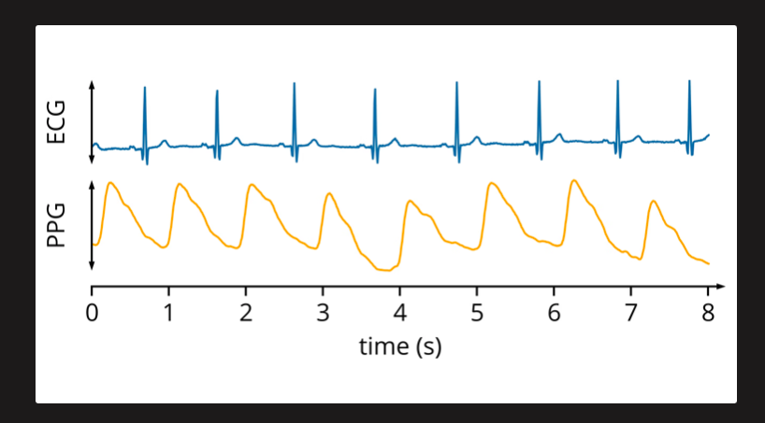

Like with heart rates, fitness trackers use PPG technology to calculate SpO₂. To understand how this is accomplished, you have to understand more precisely what SpO₂ is: the ratio of oxygen-laden hemoglobin (HbO₂) to total hemoglobin (Hb).

*Haemoglobin is the molecule in the blood that responsible with carrying oxygen around the body

Because water is the primary conductor of electricity in the body, BIA is essentially giving an estimate (based on your height, weight, and gender) of the total volume of water in the body. Most of our body water exists in our blood, muscles, and organs; very little of it is in our fat stores. In general, about 73% of our water exists in the fat-free mass of our body. By subtracting that fat-free mass from our total body weight, we can make a reasonable estimation of our body fat percentage.Because water is the primary conductor of electricity in the

body, BIA is essentially giving an estimate (based on your height, weight, and gender) of the total volume of water in the body. Most of our body water exists in our blood, muscles, and organs; very little of it is in our fat stores. In general, about 73% of our water exists in the fat-free mass of our body. By subtracting that fat-free mass from our total body weight, we can make a reasonable estimation of our body fat percentage.

.

. 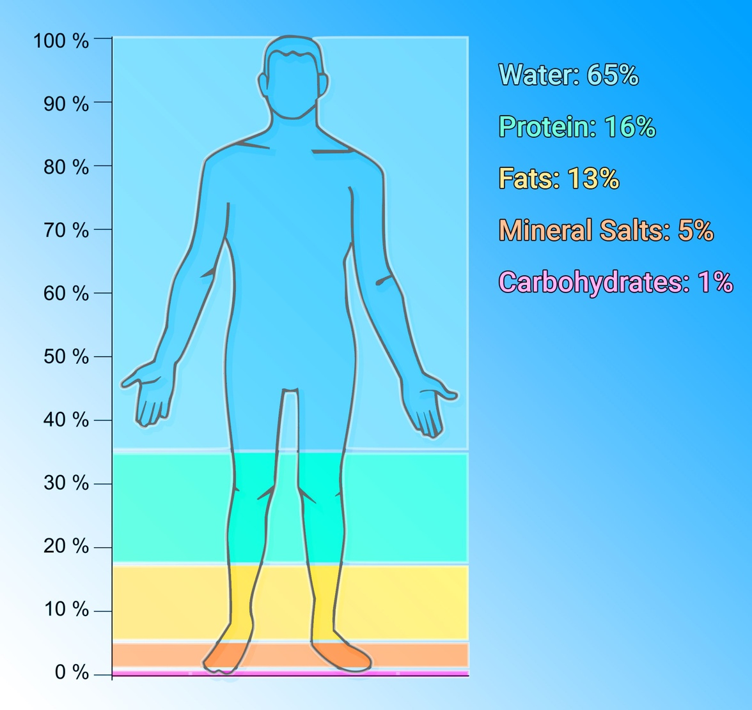

Proximity sensors are used in devices to know if you are the near the devices, and if you are not wearing the watch, the sensors alerts the device to turn off to save battery